LAB 4 REPORT
KRISHNA CHAITANYA NALLURI
16157744

Data collection from BLE Sensor Tag and Android Mobile Device:
I have used the BLE sensor tag and my android device to collect the data. Text file is generated in my android device. I downloaded and imported the app1-app3 from the material given, and using this i have collected the data.
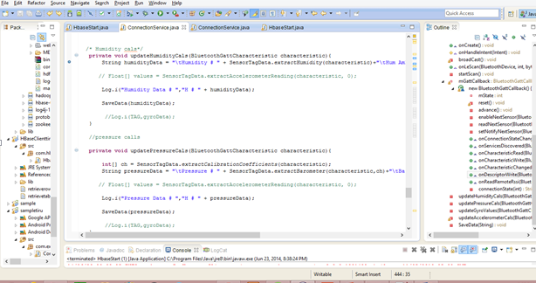

TASK 2: HBASE
Created a table in the HBASE of name tablechaitu and i have inserted the data into that table.

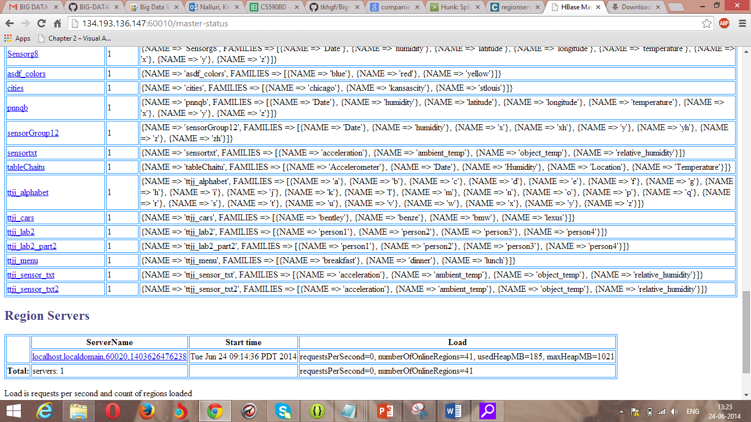

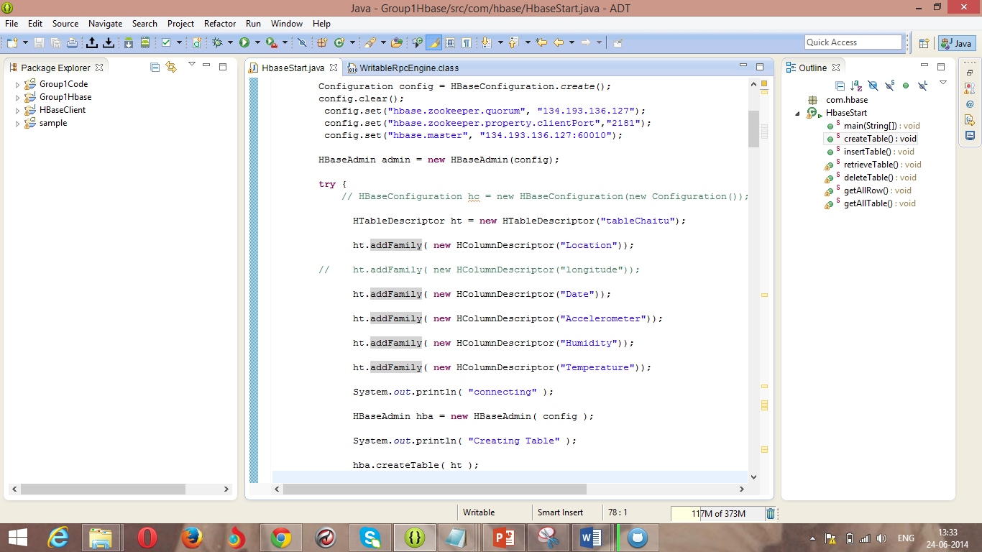
I have inserted the data which is collected from the HBASE.

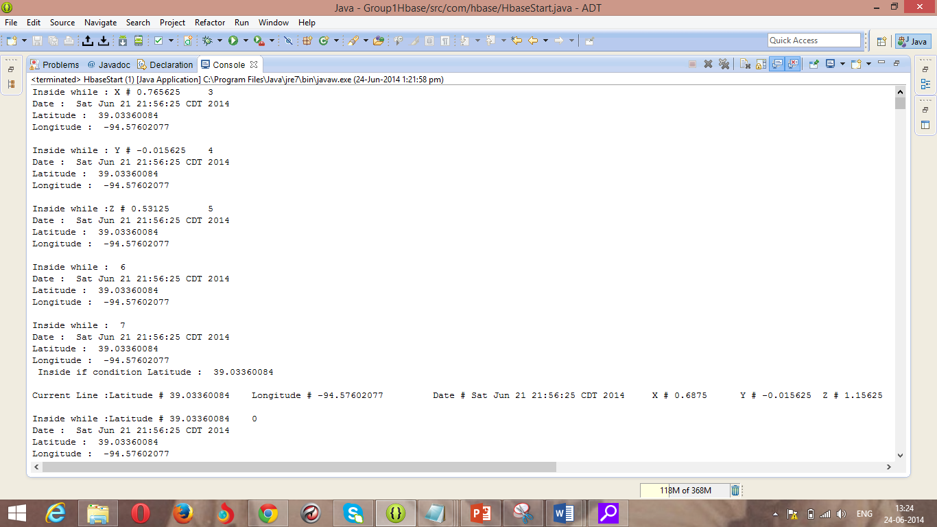
After the insertion, i have retrieved the data.

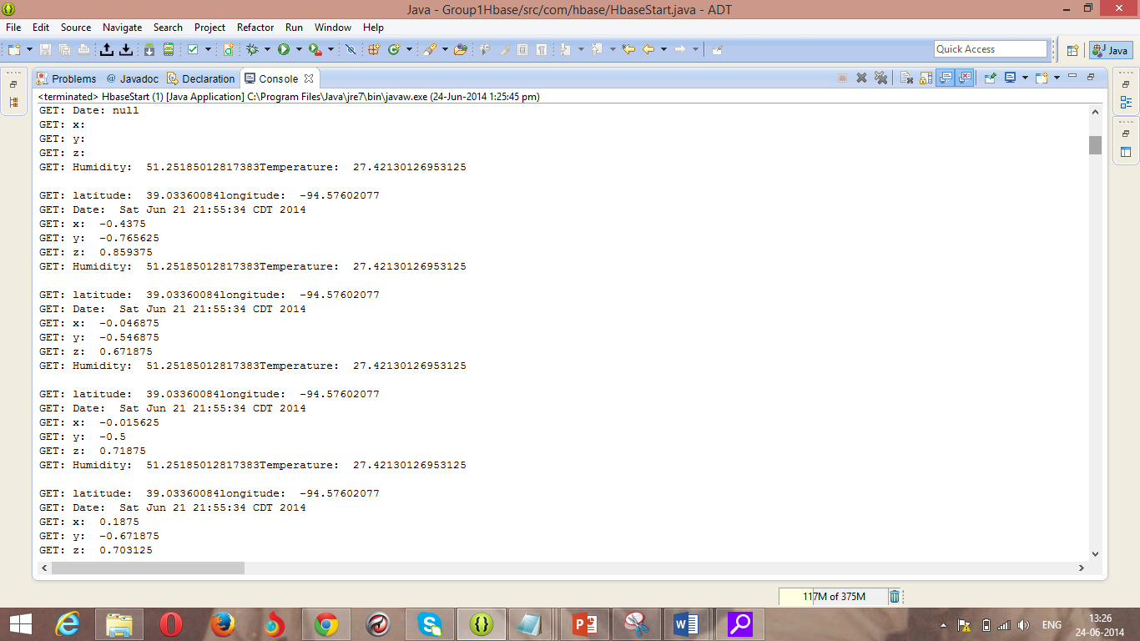

Installation of glassfish server:
We have to download the java ee eclipse. After we have installed this one go to servers tab and create new server. We have to install the Glassfish Server pattern 6 .
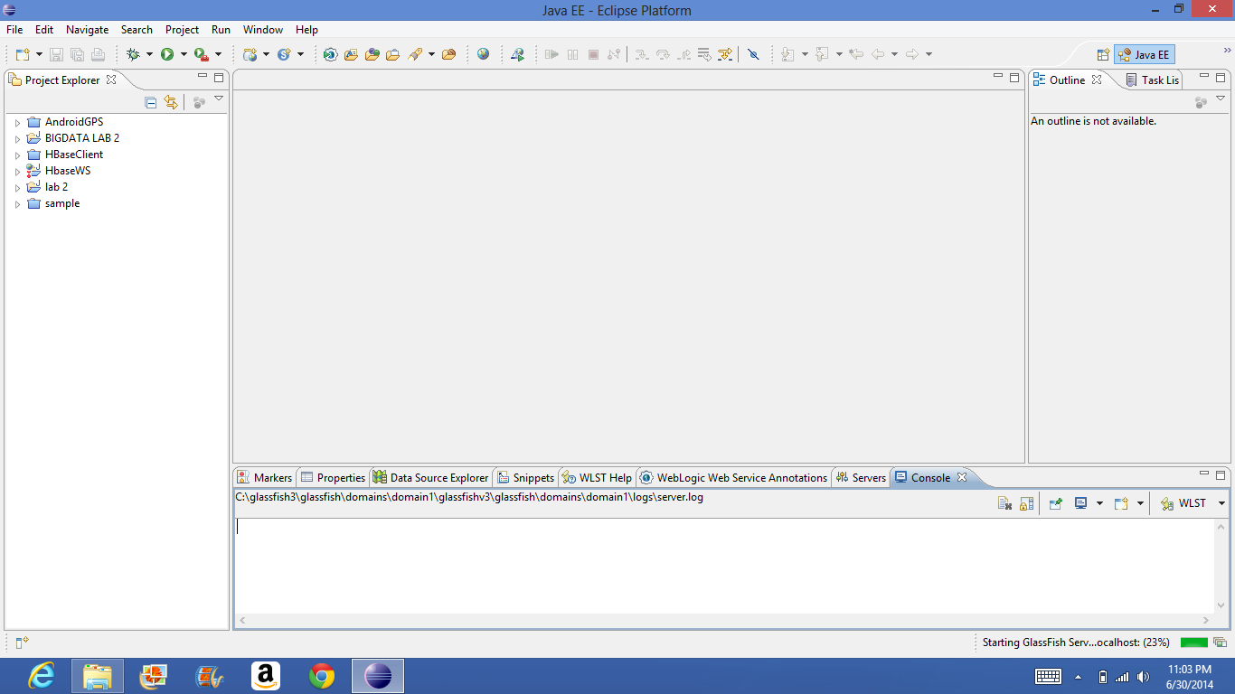

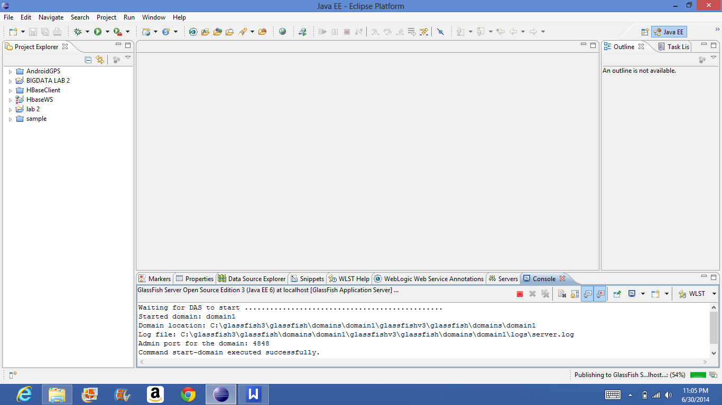

I have exported the war file and i have deployed that one into the localhost:4848.

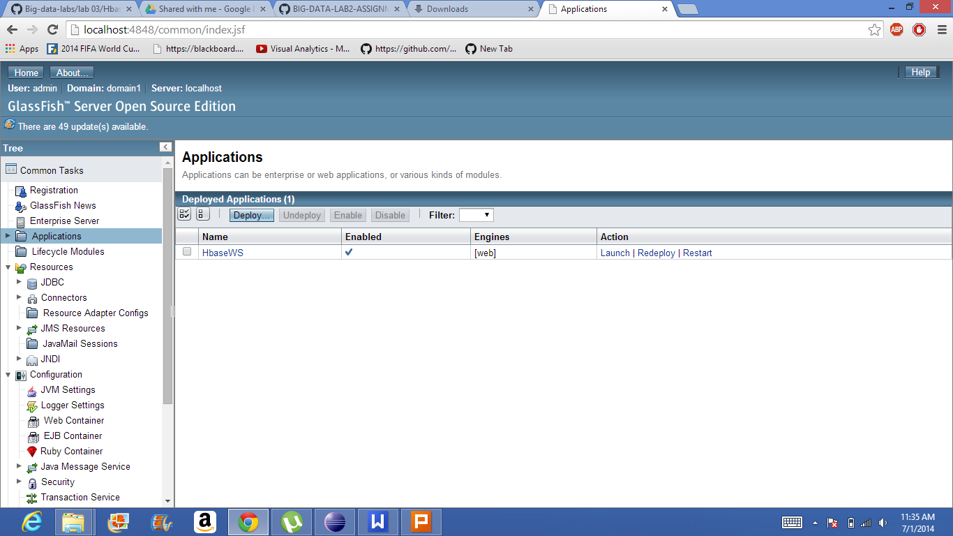

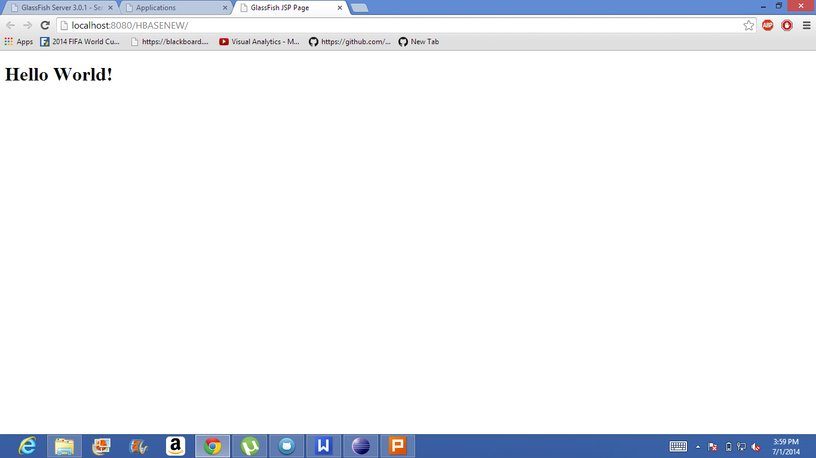

I have created the table using http://134.193.136.127:8080/HbaseWS/jaxrs/generic/hbaseCreate/KNHY30Table/GeoLocation:Date:Accelerometer
